PANCAR WAHYU SETIABI

H1D024018

SHIFT D

1. Berdasarkan tabel yang telah dibuat pada praktikum sebelumnya untuk skema orderentry tampilkan data data berikut ini:
2. Tampilkan data customers berdasarkan nama customer secara urut dari a sampai z (dari terkecil hingga terbesar)

Before:

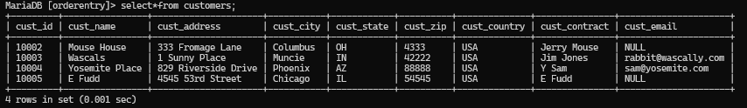

After:

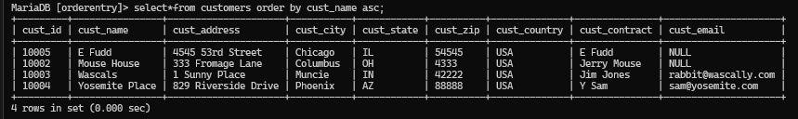

MariaDB [orderentry]> select*from customers order by cust_name asc;

+---------+----------------+---------------------+-----------+------------+----------+--------------+---------------+---------------------+

| cust_id | cust_name | cust_address | cust_city | cust_state | cust_zip | cust_country | cust_contract | cust_email |

+---------+----------------+---------------------+-----------+------------+----------+--------------+---------------+---------------------+

| 10005 | E Fudd | 4545 53rd Street | Chicago | IL | 54545 | USA | E Fudd | NULL |

| 10002 | Mouse House | 333 Fromage Lane | Columbus | OH | 4333 | USA | Jerry Mouse | NULL |

| 10003 | Wascals | 1 Sunny Place | Muncie | IN | 42222 | USA | Jim Jones | rabbit@wascally.com |

| 10004 | Yosemite Place | 829 Riverside Drive | Phoenix | AZ | 88888 | USA | Y Sam | sam@yosemite.com |

+---------+----------------+---------------------+-----------+------------+----------+--------------+---------------+---------------------+

4 rows in set (0.000 sec)

1. Tampilkan data vendor berdasarkan nama vendor dari yang terbesar ke yang terkecil, ada berapa vemdor di table vendor

Before:

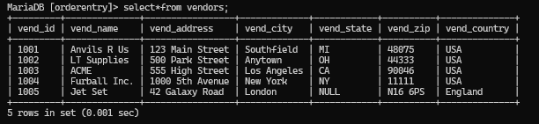

After:

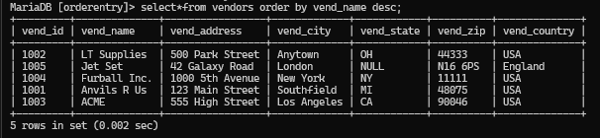

MariaDB [orderentry]> select*from vendors order by vend_name desc;

+---------+--------------+-----------------+-------------+------------+----------+--------------+

| vend_id | vend_name | vend_address | vend_city | vend_state | vend_zip | vend_country |

+---------+--------------+-----------------+-------------+------------+----------+--------------+

| 1002 | LT Supplies | 500 Park Street | Anytown | OH | 44333 | USA |

| 1005 | Jet Set | 42 Galaxy Road | London | NULL | N16 6PS | England |

| 1004 | Furball Inc. | 1000 5th Avenue | New York | NY | 11111 | USA |

| 1001 | Anvils R Us | 123 Main Street | Southfield | MI | 48075 | USA |

| 1003 | ACME | 555 High Street | Los Angeles | CA | 90046 | USA |

+---------+--------------+-----------------+-------------+------------+----------+--------------+

5 rows in set (0.002 sec)

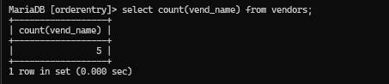

MariaDB [orderentry]> select count(vend_name) from vendors;

+------------------+

| count(vend_name) |

+------------------+

| 5 |

+------------------+

1 row in set (0.000 sec)

1. Tampilkan data orderitems berdasarkan quantity dari yang terbesar ke yang terkecil

Before:

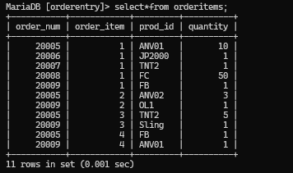

After:

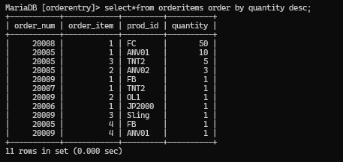

MariaDB [orderentry]> select*from orderitems order by quantity desc;

+-----------+------------+---------+----------+

| order_num | order_item | prod_id | quantity |

+-----------+------------+---------+----------+

| 20008 | 1 | FC | 50 |

| 20005 | 1 | ANV01 | 10 |

| 20005 | 3 | TNT2 | 5 |

| 20005 | 2 | ANV02 | 3 |

| 20009 | 1 | FB | 1 |

| 20007 | 1 | TNT2 | 1 |

| 20009 | 2 | OL1 | 1 |

| 20006 | 1 | JP2000 | 1 |

| 20009 | 3 | Sling | 1 |

| 20005 | 4 | FB | 1 |

| 20009 | 4 | ANV01 | 1 |

+-----------+------------+---------+----------+

11 rows in set (0.000 sec)

1. Tampilkan fungsi agregasi banyaknya, total, rata-rata, jumlah minimal, jumlah maksimal dari quantity penjualan. Data berasal dari table orderitems

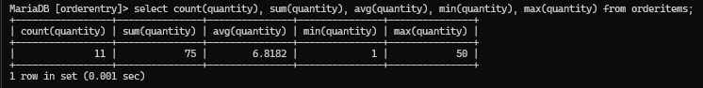

MariaDB [orderentry]> select count(quantity), sum(quantity), avg(quantity), min(quantity), max(quantity) from orderitems;

+-----------------+---------------+---------------+---------------+---------------+

| count(quantity) | sum(quantity) | avg(quantity) | min(quantity) | max(quantity) |

+-----------------+---------------+---------------+---------------+---------------+

| 11 | 75 | 6.8182 | 1 | 50 |

+-----------------+---------------+---------------+---------------+---------------+

1 row in set (0.001 sec)

1. Tampilkan data orderitems dimana quantitynya antara 5-10

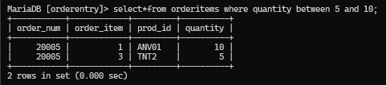

MariaDB [orderentry]> select*from orderitems where quantity between 5 and 10;

+-----------+------------+---------+----------+

| order_num | order_item | prod_id | quantity |

+-----------+------------+---------+----------+

| 20005 | 1 | ANV01 | 10 |

| 20005 | 3 | TNT2 | 5 |

+-----------+------------+---------+----------+

2 rows in set (0.000 sec)

1. Tampilkan data vendor id yang countrynya USA

Before:

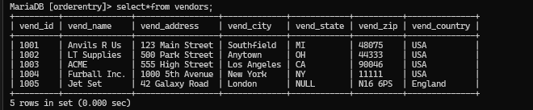

After:

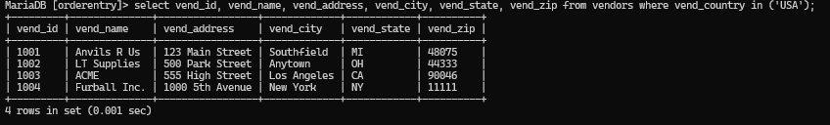

MariaDB [orderentry]> select vend_id, vend_name, vend_address, vend_city, vend_state, vend_zip from vendors where vend_country in ('USA');

+---------+--------------+-----------------+-------------+------------+----------+

| vend_id | vend_name | vend_address | vend_city | vend_state | vend_zip |

+---------+--------------+-----------------+-------------+------------+----------+

| 1001 | Anvils R Us | 123 Main Street | Southfield | MI | 48075 |

| 1002 | LT Supplies | 500 Park Street | Anytown | OH | 44333 |

| 1003 | ACME | 555 High Street | Los Angeles | CA | 90046 |

| 1004 | Furball Inc. | 1000 5th Avenue | New York | NY | 11111 |

+---------+--------------+-----------------+-------------+------------+----------+

4 rows in set (0.001 sec)

1. Tampilkan nama produk dan nama vndor pada product dan vendors yang mengandung huruf p

P pada products:

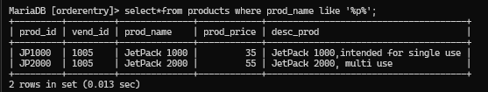

MariaDB [orderentry]> select*from products where prod_name like '%p%';

+---------+---------+--------------+------------+--------------------------------------+

| prod_id | vend_id | prod_name | prod_price | desc_prod |

+---------+---------+--------------+------------+--------------------------------------+

| JP1000 | 1005 | JetPack 1000 | 35 | JetPack 1000,intended for single use |

| JP2000 | 1005 | JetPack 2000 | 55 | JetPack 2000, multi use |

+---------+---------+--------------+------------+--------------------------------------+

2 rows in set (0.013 sec)

P pada vendors:

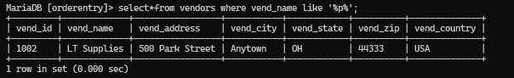

MariaDB [orderentry]> select*from vendors where vend_name like '%p%';

+---------+-------------+-----------------+-----------+------------+----------+--------------+

| vend_id | vend_name | vend_address | vend_city | vend_state | vend_zip | vend_country |

+---------+-------------+-----------------+-----------+------------+----------+--------------+

| 1002 | LT Supplies | 500 Park Street | Anytown | OH | 44333 | USA |

+---------+-------------+-----------------+-----------+------------+----------+--------------+

1 row in set (0.000 sec)

1. Tampilkan prod_name sebagai nama produk dan prod_price sebagai Harganya dari table product

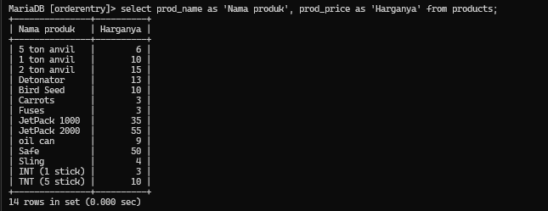

MariaDB [orderentry]> select prod_name as 'Nama produk', prod_price as 'Harganya' from products;

+---------------+----------+

| Nama produk | Harganya |

+---------------+----------+

| 5 ton anvil | 6 |

| 1 ton anvil | 10 |

| 2 ton anvil | 15 |

| Detonator | 13 |

| Bird Seed | 10 |

| Carrots | 3 |

| Fuses | 3 |

| JetPack 1000 | 35 |

| JetPack 2000 | 55 |

| oil can | 9 |

| Safe | 50 |

| Sling | 4 |

| INT (1 stick) | 3 |

| TNT (5 stick) | 10 |

+---------------+----------+

14 rows in set (0.000 sec)

1. Operasikan perintah SQ untuk menampilkan:
2. Tanggal sekarang menjadi tanggal hari ini

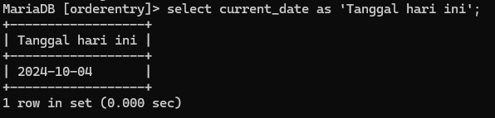

MariaDB [orderentry]> select current_date as 'Tanggal hari ini';

+------------------+

| Tanggal hari ini |

+------------------+

| 2024-10-04 |

+------------------+

1 row in set (0.000 sec)

1. Jam sekarang

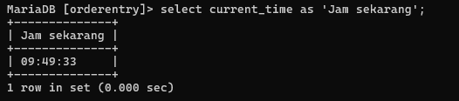

MariaDB [orderentry]> select current_time as 'Jam sekarang';

+--------------+

| Jam sekarang |

+--------------+

| 09:49:33 |

+--------------+

1 row in set (0.000 sec)

1. Jam sekarang – jam awal masuk praktikum

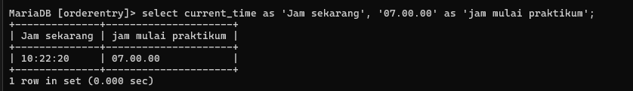

MariaDB [orderentry]> select current_time as 'Jam sekarang', '07.00.00' as 'jam mulai praktikum';

+--------------+---------------------+

| Jam sekarang | jam mulai praktikum |

+--------------+---------------------+

| 10:22:20 | 07.00.00 |

+--------------+---------------------+

1 row in set (0.000 sec)

1. Tahun sekarang – tahun lahir anda

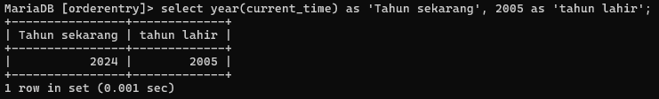

MariaDB [orderentry]> select year(current_time) as 'Tahun sekarang', 2005 as 'tahun lahir';

+----------------+-------------+

| Tahun sekarang | tahun lahir |

+----------------+-------------+

| 2024 | 2005 |

+----------------+-------------+

1 row in set (0.001 sec)